Maxwell's Alternative
  - Prologue 7 of Quantum, Actually, Volume 2: A QED Course
Lothar J. Musiol

E, B, and the wave equation are the right language when photons are many; they are not a rival theory, and they are not the first language of this book

First edition, 2026

How to use this prologue
Prologues 1–6 described light as photons and arrows, and electrons as the things that emit and absorb them. There is another complete language for the same facts when the clicks are too many to count: Maxwell's. Electric and magnetic fields, four equations, waves at speed c. Lesson 7 computes that language in full. This prologue places it as an alternative, not as a replacement, and says when to use which. Expect four to six hours.

Learning objectives
- State Maxwell's four equations in words, as the alternative description of light and charge.
- Identify electromagnetic waves in vacuum as the many-photon limit of Prologue 1's clicks.
- Explain why a single-photon interference pattern still follows Maxwell's intensities, while each detection remains a click.
- State that this course keeps both: −¼F_{μν}F^{μν} in Lesson 42 is Maxwell's kinetic term, and the wavy line in a diagram is Prologue 5's photon.
- Preview that E and B will be derived from A in Lesson 8, which is the door Mead's later view walks through.

Notation and conventions
Symbol | Meaning
E, B | Electric and magnetic fields (Lesson 7)
c | Wave speed in vacuum, one in this course's units
many-photon limit | Occupation so large that only averages of clicks are seen

1 The four equations, as an alternative
Maxwell's alternative says: space is filled with two vector fields, E and B. Charge density is the source of E. There are no magnetic charges, so B lines close. A changing B makes a circulating E (Faraday). A current, and a changing E, make a circulating B (Ampère–Maxwell). Light is a wave of E and B that those equations permit in empty space, travelling at a speed fixed by the constants in the equations.
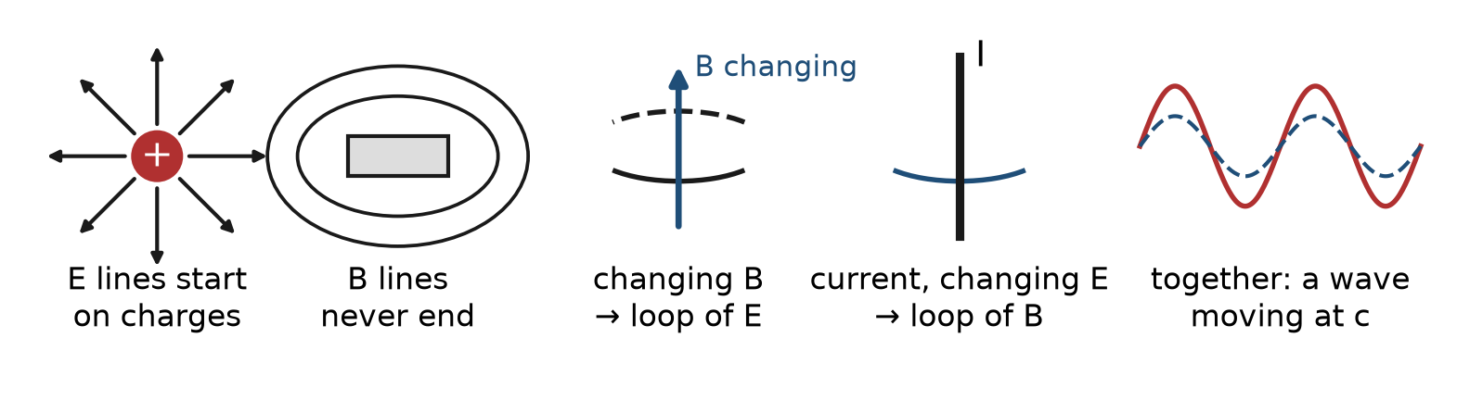
Figure P7.1. Maxwell's four statements in pictures: field lines of E start and end on charges; lines of B never end; a changing B is circled by E; a current or changing E is circled by B. Together they allow a wave that travels at c.
That is a different inventory from "photons and arrows." It is extremely good at motors, radio antennas, and the energy in a capacitor. It does not, by itself, explain why a photomultiplier clicks in lumps.
Why fields first? Partly history. Faraday pictured lines of force filling the space around magnets and charges. Maxwell, building on him, actually gave the potentials a prominent place in his equations; it was Oliver Heaviside, in the 1880s, who tidied them into today's four equations for E and B and removed the potentials wherever he could, because fields could be measured directly and potentials could not. For classical circuits and waves that was a reasonable choice. It was a choice, though, not a law of nature, and quantum mechanics is where it stops being free (Section 4).

2 When the alternative is the right tool
If a radio antenna radiates 10³⁰ photons per second, nobody is counting clicks. The Poynting vector of Lesson 7, the wave equation, and the boundary conditions on a metal are the working theory. The arrow picture still sits underneath: each photon's arrows, added, produce an intensity that Maxwell already computed as |E|². The correspondence is:
$${\left(arrow length\right)}^{2} ↔ energy flux in the wave \left(up to a density of photons\right)$$
Worked example 1
A double-slit pattern built one photon at a time eventually draws the same bands Maxwell would have drawn for a continuous wave. Why is that not a contradiction? Maxwell's intensity is the probability map for the clicks. The alternative language predicts the map; the photon language predicts the lumps that fill it in. Use Maxwell for the map when the field is classical. Use arrows when the question is a single click, a single vertex, or a loop.

3 Not a rival, a limit
This course will not choose Maxwell or Feynman. Lesson 42's Lagrangian contains Maxwell's field term −¼F² and the electron term that emits and absorbs the quanta of that field. Prologue 5's wavy line is a quantum of the Maxwell field. If you start from Maxwell alone you must later explain clicks. If you start from clicks you must later recover waves. Starting with clicks is the choice of this book; Lesson 7 still has to be done, because the wave equation, polarization, and energy density are how classical apparatus is calculated.

4 The door to potentials, and to Mead
Maxwell can be rewritten so that E and B come from a scalar potential φ and a vector potential A (Lesson 8). That rewrite looks optional classically — a convenience for solving the wave equation. It is not optional quantum-mechanically: the Schrödinger and Dirac equations couple to A, not to E and B. Carver Mead's view, placed later as an Interlude after Lesson 41, takes that fact as primary: electromagnetism is the phase standard of charged matter, and E, B are derived. Read Prologue 7 as the classical alternative; read the Interlude as the quantum alternative to treating E and B as the primitive objects. The Feynman diagrams of Prologue 5 survive in both.

Connections to QED
Result of this prologue | Where it is used
Maxwell as many-photon language | Lesson 7, in full
Waves ↔ |E|² as probability map | Prologues 1–2
E, B from A | Lesson 8; Mead Interlude after Lesson 41
−¼F² in ℒ | Lesson 42

Summary
- Maxwell's alternative: two fields, four equations, waves at c.
- It is the right tool when photons are many.
- A one-photon pattern still follows Maxwell intensities.
- This course's Lagrangian contains Maxwell, and its diagrams contain photons.
- Potentials make E and B derived; Mead's view of that fact comes after Lesson 41.

Exercises
No | Problem
1 | Extension. State the four Maxwell equations in words.
2 | Core. What travels at c in the Maxwell language?
3 | Core. When is Maxwell the wrong first language for a photomultiplier?
4 | Extension. How can a one-photon double slit agree with Maxwell?
5 | Core. Where does this course write Maxwell into a Lagrangian?
6 | Core. Why will Lesson 8 bother with φ and A if E and B already work classically?
7 | Core. What, in one sentence, will Mead later say that this prologue does not yet say?
8 | Challenge. A cavity mode with mean photon number 10⁻³. Which language first?

Solutions
Attempt each exercise before reading its solution. If you are stuck, read only the first sentence of the solution, then try again.
1. Gauss for E (charge sources E); Gauss for B (no magnetic charge); Faraday (changing B makes E); Ampère–Maxwell (current and changing E make B).
2. A transverse wave of E and B.
3. When the question is a single click, not an average flux.
4. Maxwell's |E|² is the probability density for the clicks; the clicks still come one by one.
5. Lesson 42, the −¼F_{μν}F^{μν} term.
6. Quantum equations couple to potentials; gauge symmetry of QED is a statement about A_{μ}.
7. That A, as the phase standard of matter, is primitive, and E, B are bookkeeping.
8. Arrows (or the quantum field of Lesson 38): the occupation is not classical.

Mastery checklist
- I can state Maxwell's alternative in four sentences and name when to use it.
- I can relate |E|² to (arrow length)² without erasing photons.
- I know Mead's A-first view is later, after Lesson 41, not a substitute for this prologue.

Next lesson
Prologue 8 names the arrows with kets and bras and writes the Schrödinger equation, the law that turns them; Prologue 9 then connects them to the S-matrix and Feynman diagrams, still before Lesson 1's algebra.

